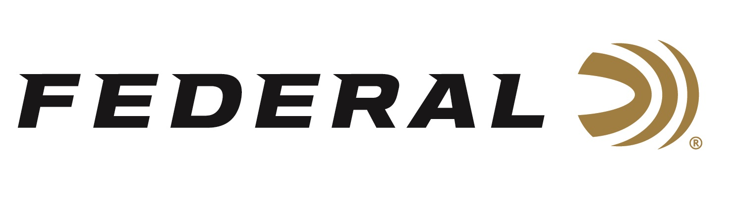

FOR IMMEDIATE RELEASE

Law Enforcement Hero featured on Federal Ammunition’s “It’s Federal Season” Podcast

ANOKA, Minnesota – April 16, 2020 – Hear about a life-and-death encounter from an officer who survived one. On this special episode, Federal shares the microphone with Special Agent Bill Gray, a former Wisconsin county investigator who used HST to defend himself during an attack that left 14 stab wounds in his face, neck and hands. Gray was called to assist in locating a runaway girl when a series of events led to the vicious attack and eventual death of the suspect.

Episode No. 6 - Bill Gray- Law Enforcement Hero
https://www.federalpremium.com/podcast.html

“It was such an honor to hear his story in person,” said Jason Vanderbrink, President of Federal Ammunition. “Bill Gray details a harrowing experience that verifies why every American should be proud of the job law enforcement does each and every day for our communities.”

Gray relives the day with great detail, has high praise for the Federal HST duty ammunition used to defend himself, and provides advice for those who want to pursue law enforcement as a career. Since surviving the attack, Gray has been awarded the Law Enforcement Purple Heart — an honor given to officers wounded in the line of duty.

HST Survival Story (Related Video on YouTube)
https://youtu.be/e2S_g7Ok0J8

In the Tech Talk segment, Larry Head, Chief Engineer discusses the terminal performance of Federal’s HST and Speer’s Gold Dot ammunition and why these are staples of law enforcement agencies across the United States. Head address the events that led the FBI to set a performance standard for duty ammunition. Before signing off, find out what promotions are available for consumers and where consumers can meet with our ammunition team to talk all things ammunition. Look for more episodes on Federal’s website or where you find your favorite podcasts.

Federal ammunition can be found at dealers nationwide or purchased online direct from Federal. For more information on all products from Federal or to shop online, visit www.federalpremium.com.

Press Release Contact: JJ Reich
Senior Manager – Press Relations
E-mail: VistaPressroom@VistaOutdoor.com

About Federal Ammunition
Federal, headquartered in Anoka, MN, is a brand of Vista Outdoor Inc., an outdoor sports and recreation company. From humble beginnings nestled among the lakes and woods of Minnesota, Federal Ammunition has evolved into one of the world's largest producers of sporting ammunition. Beginning in 1922, founding president, Charles L. Horn, paved the way for our success. Today, Federal carries on Horn's vision for quality products and service with the next generation of outdoorsmen and women. We maintain our position as experts in the science of ammunition production. Every day we manufacture products to enhance our customers' shooting experience while partnering with the conservation organizations that protect and support our outdoor heritage. We offer thousands of options in our Federal Premium and Federal® lines-it's what makes us the most complete ammunition company in the business and provides our customers with a choice no matter their pursuit.

